Data visualizations
Charging Stations by region and type in India:
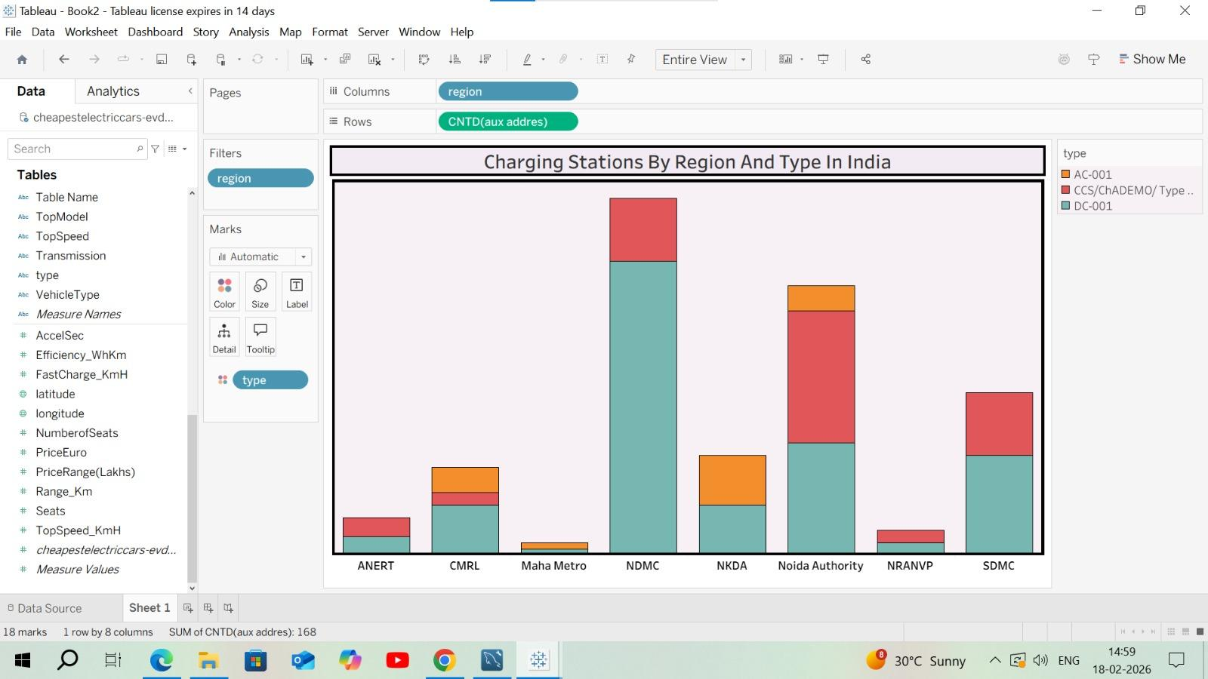

EV Charging stations map of India: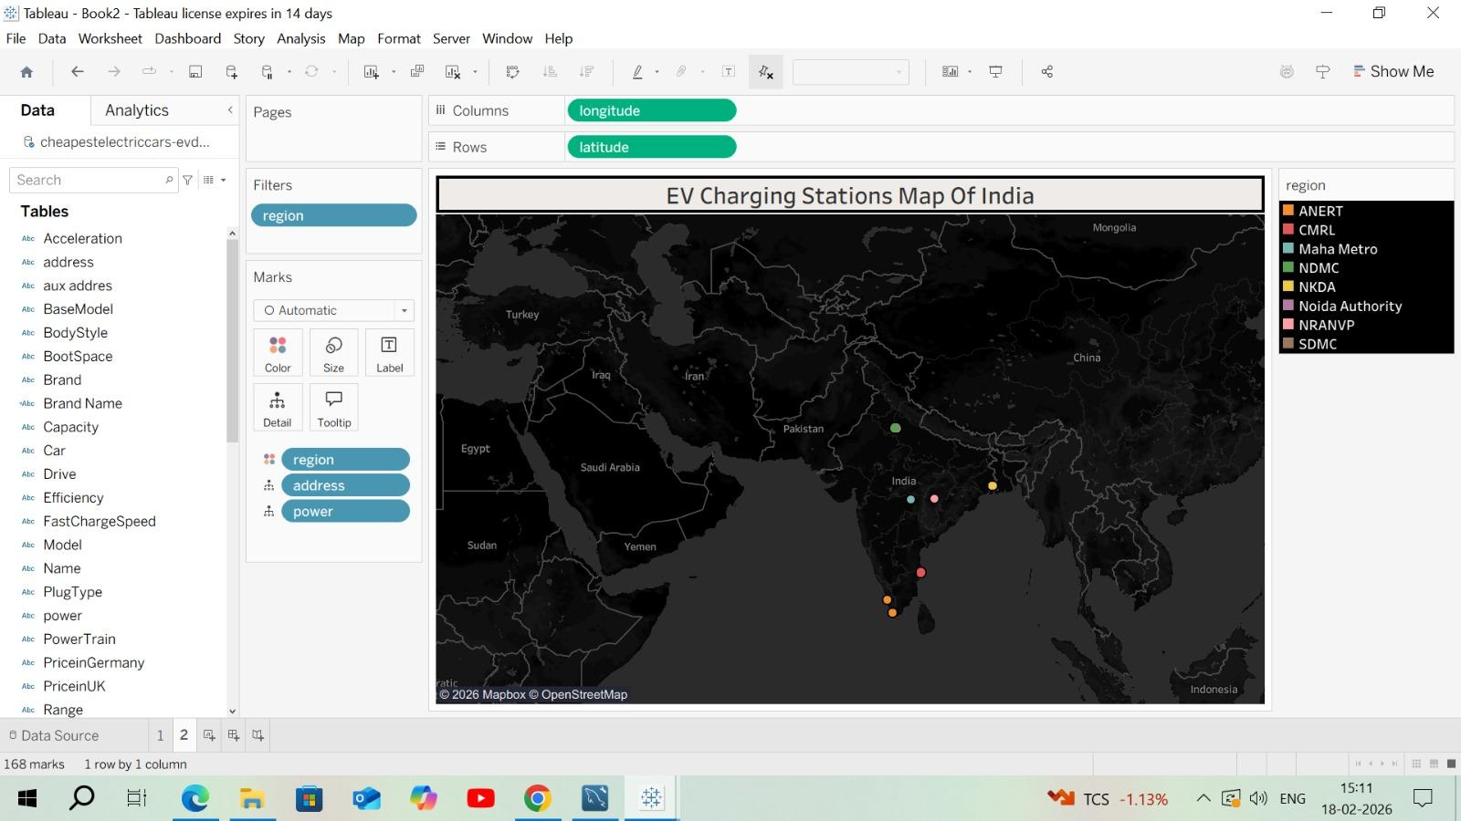

Different EV cars in India :
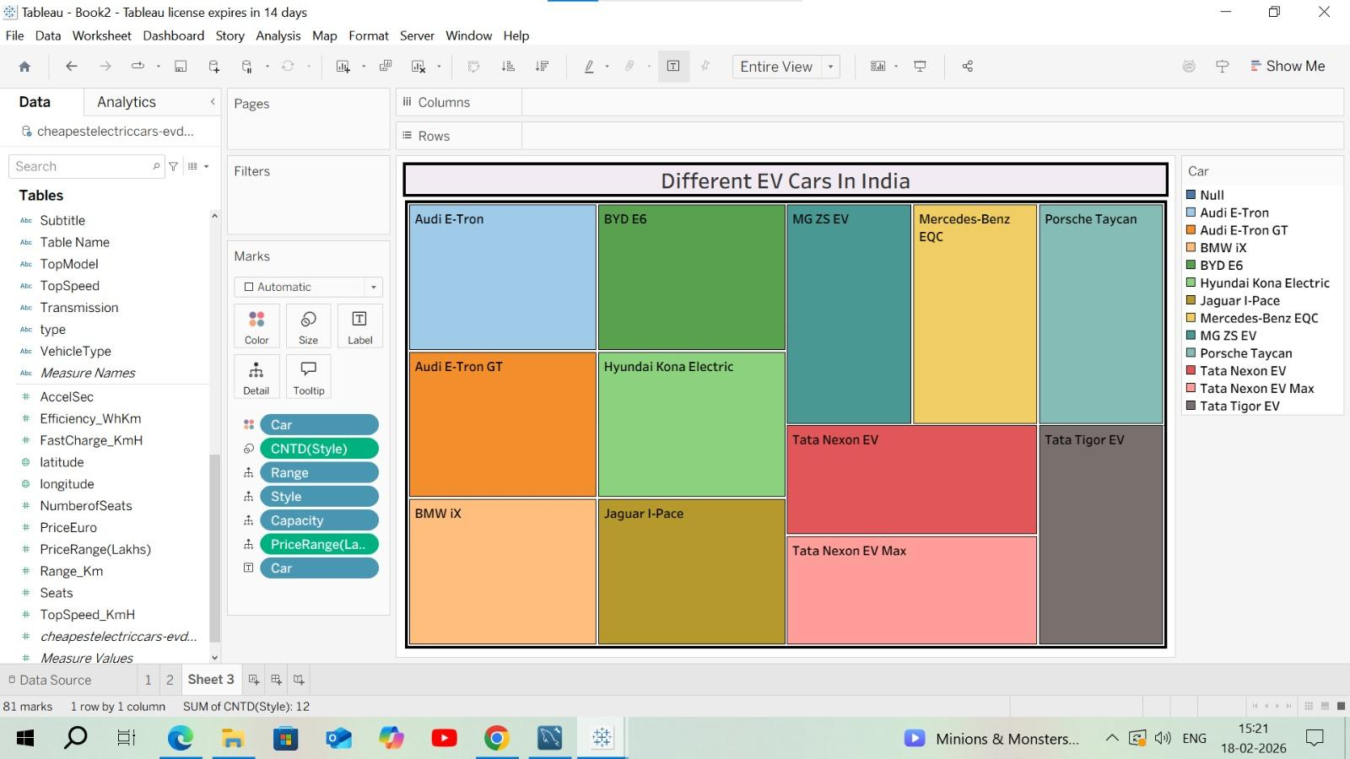

Top speed for different Brands:
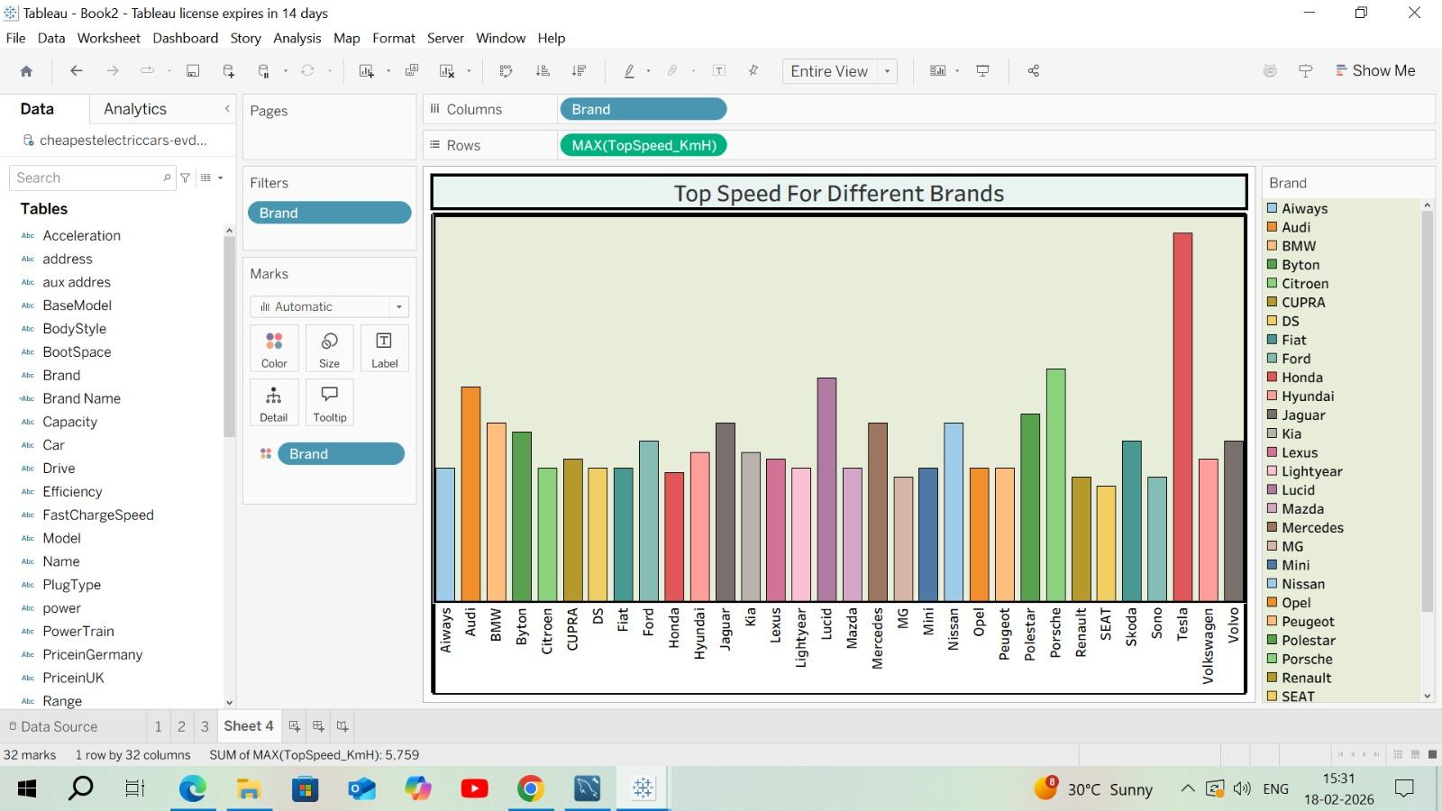
Price for different cars in India:

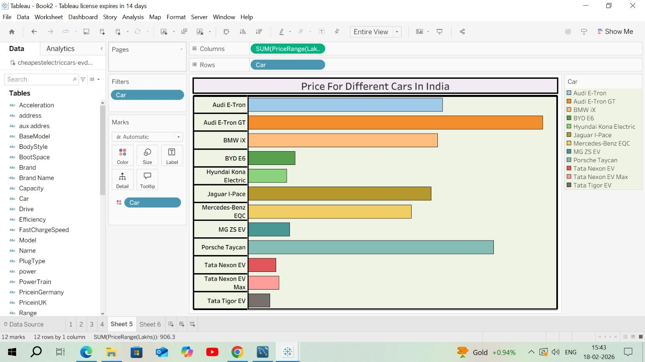

Top 10 most efficient EV Brands:
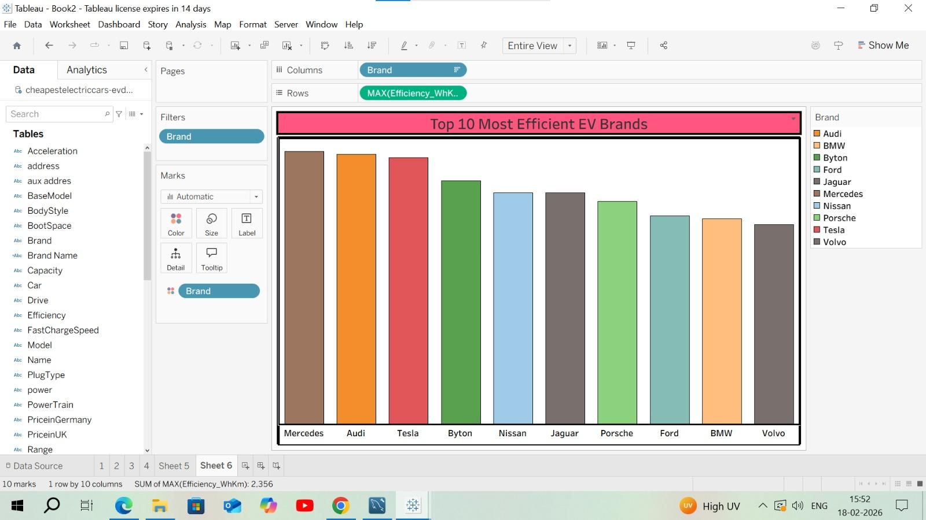

Brands according to Body style:
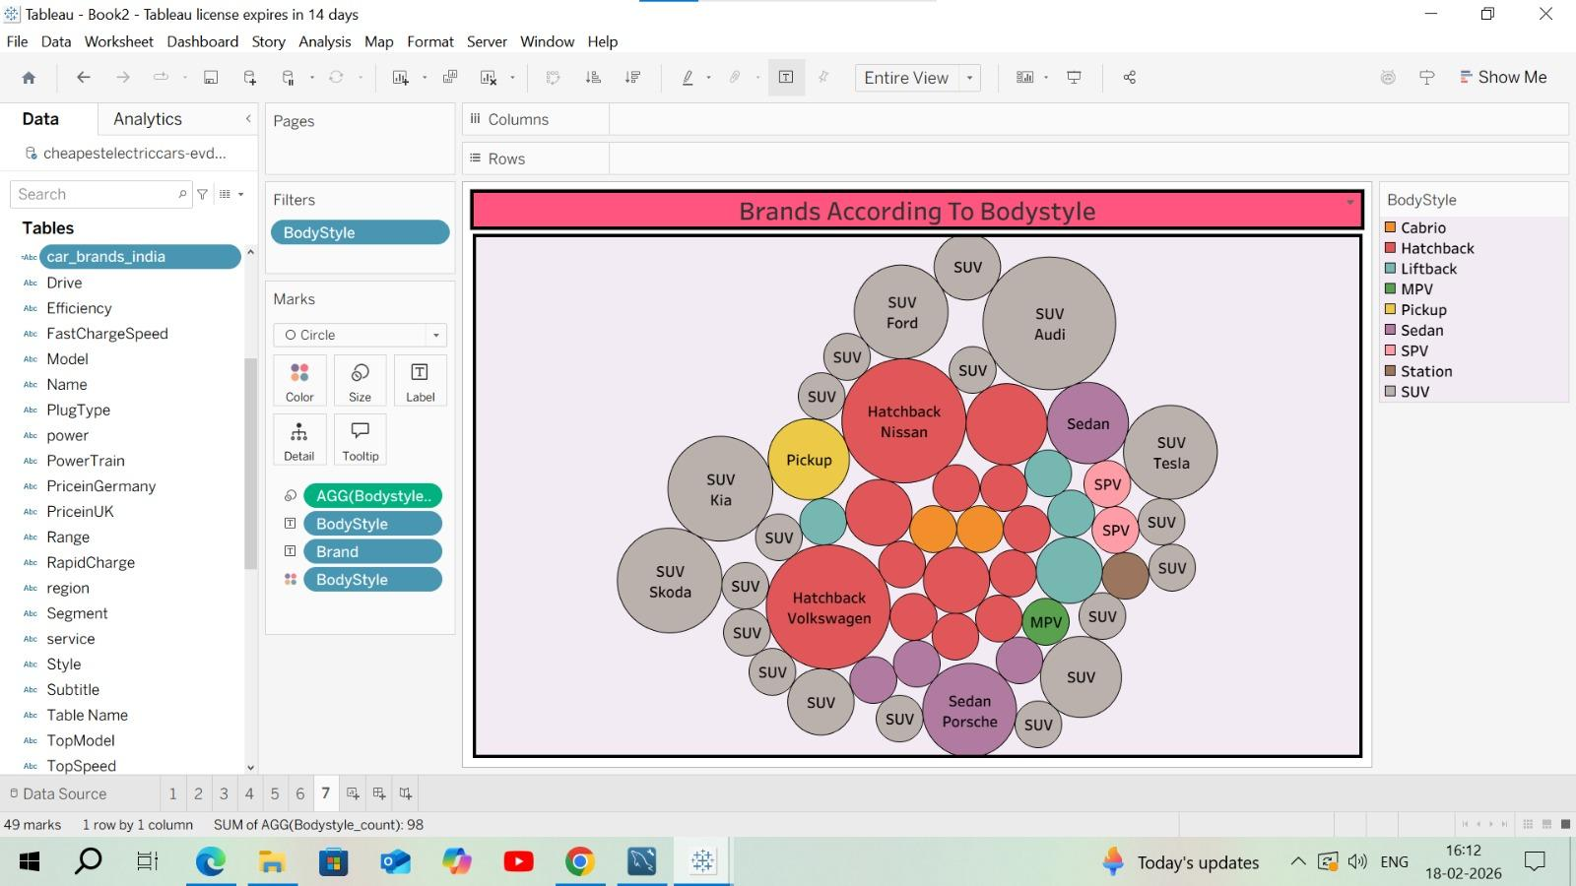

Brand filtered by PowerTrain type:
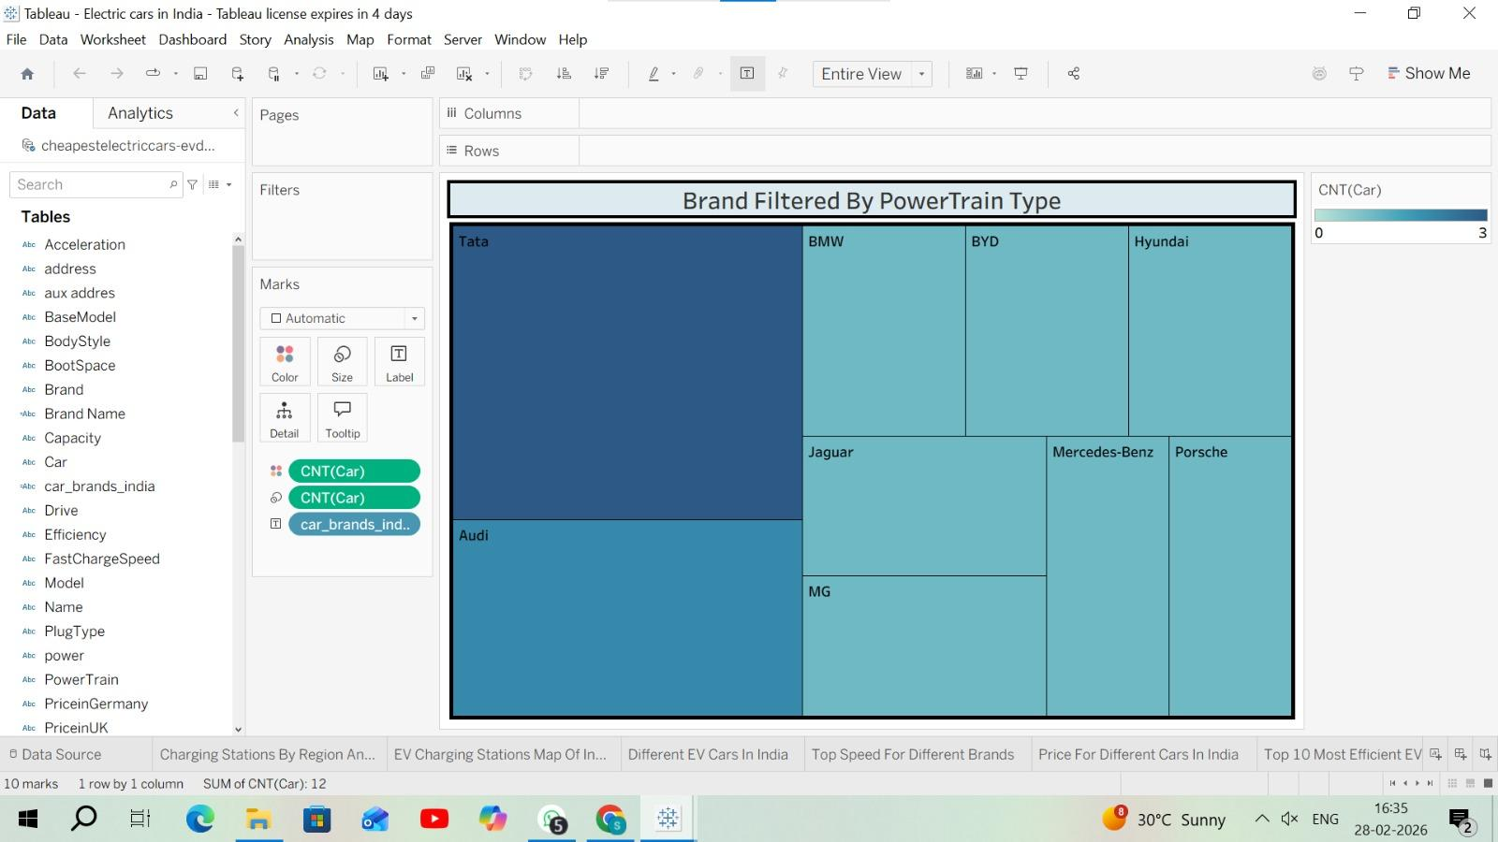

No of models by each brand:
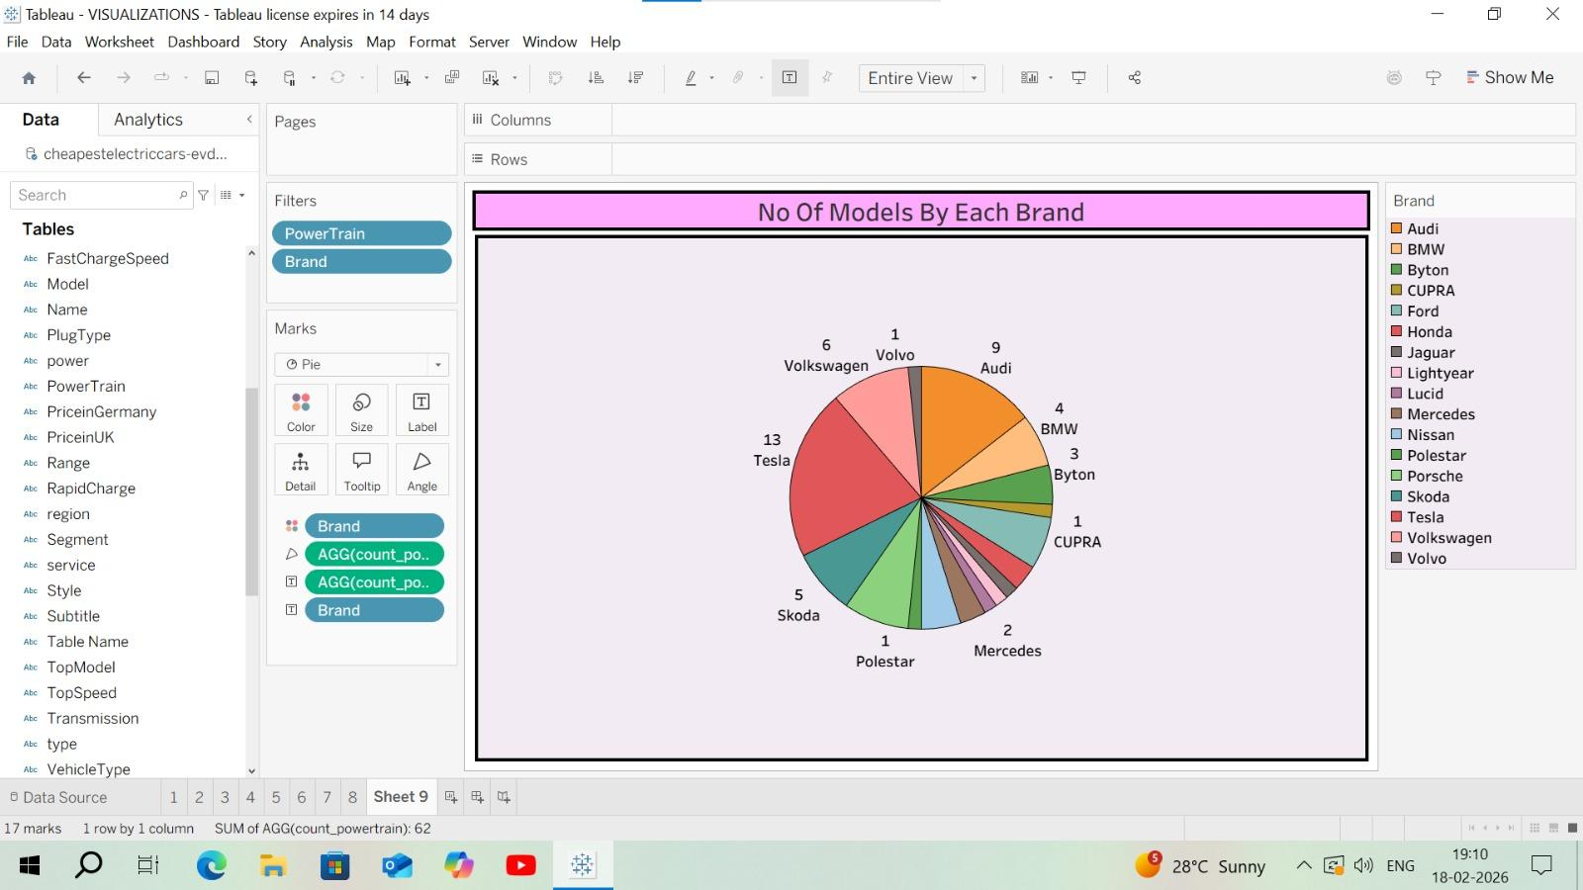

Summary card for Different brands of EV Cars globally:
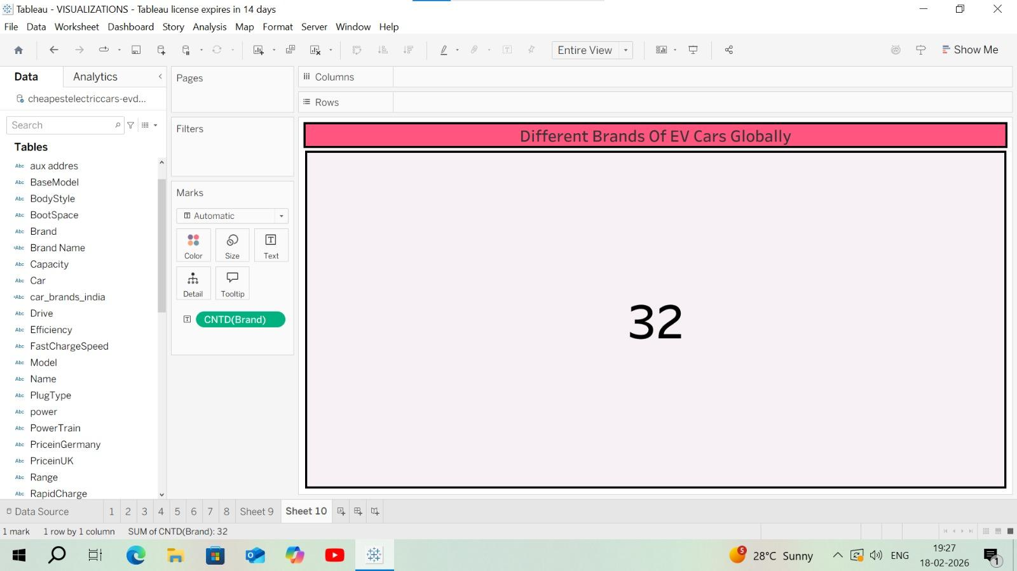

Summary card for Different brands of EV Cars in India:
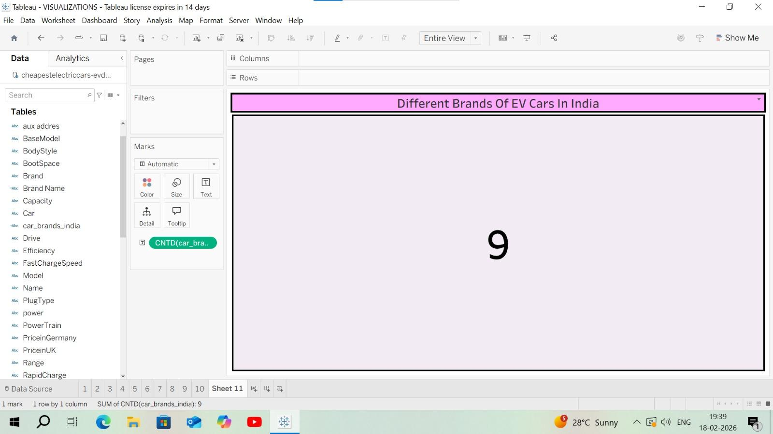

Dashboard Publishing:

https://public.tableau.com/app/profile/kinjarapu.sukanya/viz/StoryElectriccarsinIndia/Dashboard1

Story:
https://public.tableau.com/app/profile/kinjarapu.sukanya/viz/ElectriccarsinIndia/StoryofElectriccarsinIndia

Flask
https://drive.google.com/drive/folders/1NrBRmkHZGq1LndI04yspeFUn8awLywVn?usp=sharing

